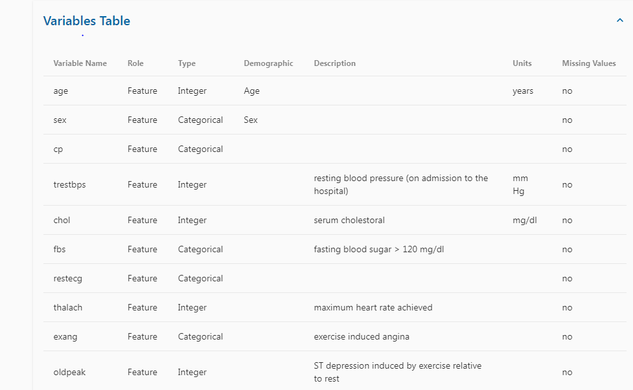

***Additional Variable Information***

**Only 14 attributes used:**

1. #3 (age)

2. #4 (sex)

3. #9 (cp)

4. #10 (trestbps)

5. #12 (chol)

6. #16 (fbs)

7. #19 (restecg)

8. #32 (thalach)

9. #38 (exang)

10. #40 (oldpeak)

11. #41 (slope)

12. #44 (ca)

13. #51 (thal)

14. #58 (num) (the predicted attribute)

**Complete attribute documentation**:

1 id: patient identification number 2 ccf: social security number (I replaced this with a dummy value of 0) 3 age: age in years 4 sex: sex (1 = male; 0 = female) 5 painloc: chest pain location (1 = substernal; 0 = otherwise) 6 painexer (1 = provoked by exertion; 0 = otherwise) 7 relrest (1 = relieved after rest; 0 = otherwise) 8 pncaden (sum of 5, 6, and 7) 9 cp: chest pain type -- Value 1: typical angina -- Value 2: atypical angina -- Value 3: non-anginal pain -- Value 4: asymptomatic 10 trestbps: resting blood pressure (in mm Hg on admission to the hospital) 11 htn 12 chol: serum cholestoral in mg/dl 13 smoke: I believe this is 1 = yes; 0 = no (is or is not a smoker) 14 cigs (cigarettes per day) 15 years (number of years as a smoker) 16 fbs: (fasting blood sugar > 120 mg/dl) (1 = true; 0 = false) 17 dm (1 = history of diabetes; 0 = no such history) 18 famhist: family history of coronary artery disease (1 = yes; 0 = no) 19 restecg: resting electrocardiographic results -- Value 0: normal -- Value 1: having ST-T wave abnormality (T wave inversions and/or ST elevation or depression of > 0.05 mV) -- Value 2: showing probable or definite left ventricular hypertrophy by Estes' criteria 20 ekgmo (month of exercise ECG reading) 21 ekgday(day of exercise ECG reading) 22 ekgyr (year of exercise ECG reading) 23 dig (digitalis used furing exercise ECG: 1 = yes; 0 = no) 24 prop (Beta blocker used during exercise ECG: 1 = yes; 0 = no) 25 nitr (nitrates used during exercise ECG: 1 = yes; 0 = no) 26 pro (calcium channel blocker used during exercise ECG: 1 = yes; 0 = no) 27 diuretic (diuretic used used during exercise ECG: 1 = yes; 0 = no) 28 proto: exercise protocol 1 = Bruce 2 = Kottus 3 = McHenry 4 = fast Balke 5 = Balke 6 = Noughton 7 = bike 150 kpa min/min (Not sure if "kpa min/min" is what was written!) 8 = bike 125 kpa min/min 9 = bike 100 kpa min/min 10 = bike 75 kpa min/min 11 = bike 50 kpa min/min 12 = arm ergometer 29 thaldur: duration of exercise test in minutes 30 thaltime: time when ST measure depression was noted 31 met: mets achieved 32 thalach: maximum heart rate achieved 33 thalrest: resting heart rate 34 tpeakbps: peak exercise blood pressure (first of 2 parts) 35 tpeakbpd: peak exercise blood pressure (second of 2 parts) 36 dummy 37 trestbpd: resting blood pressure 38 exang: exercise induced angina (1 = yes; 0 = no) 39 xhypo: (1 = yes; 0 = no) 40 oldpeak = ST depression induced by exercise relative to rest 41 slope: the slope of the peak exercise ST segment -- Value 1: upsloping -- Value 2: flat -- Value 3: downsloping 42 rldv5: height at rest 43 rldv5e: height at peak exercise 44 ca: number of major vessels (0-3) colored by flourosopy 45 restckm: irrelevant 46 exerckm: irrelevant 47 restef: rest raidonuclid (sp?) ejection fraction 48 restwm: rest wall (sp?) motion abnormality 0 = none 1 = mild or moderate 2 = moderate or severe 3 = akinesis or dyskmem (sp?) 49 exeref: exercise radinalid (sp?) ejection fraction 50 exerwm: exercise wall (sp?) motion 51 thal: 3 = normal; 6 = fixed defect; 7 = reversable defect 52 thalsev: not used 53 thalpul: not used 54 earlobe: not used 55 cmo: month of cardiac cath (sp?) (perhaps "call") 56 cday: day of cardiac cath (sp?) 57 cyr: year of cardiac cath (sp?) 58 num: diagnosis of heart disease (angiographic disease status) -- Value 0: < 50% diameter narrowing -- Value 1: > 50% diameter narrowing (in any major vessel: attributes 59 through 68 are vessels) 59 lmt 60 ladprox 61 laddist 62 diag 63 cxmain 64 ramus 65 om1 66 om2 67 rcaprox 68 rcadist 69 lvx1: not used 70 lvx2: not used 71 lvx3: not used 72 lvx4: not used 73 lvf: not used 74 cathef: not used 75 junk: not used 76 name: last name of patient (I replaced this with the dummy string "name")